|  |  |  |  |  |  |
| --- | --- | --- | --- | --- | --- |
| Date | 12-Dec-22 | | | Tester Name | Mayuri Patel |
| Environment | Penfax - Test | | | Login used |  |
| Operating System | Select OS | Version: | Update: | | |
| Software Used | Select Software | Version: | Update: | | |
| Select Software | Version: | Update: | | |
| Release version | 22.4.1 | | | | |
| Title |  | | | | |
| Test Type | Regression | | | | |
| Test Scenario | Process Demographics by Investment Fund | | | | |
|  |  | | | | |
| Expected Results |  | | | | |
| Pass/Fail | Pass | | | JIRA# | N/A |

Describe your steps with screenshots:

Go to Batch Processes

Batch Process Type PEPP Demographics by Investment Fund Report

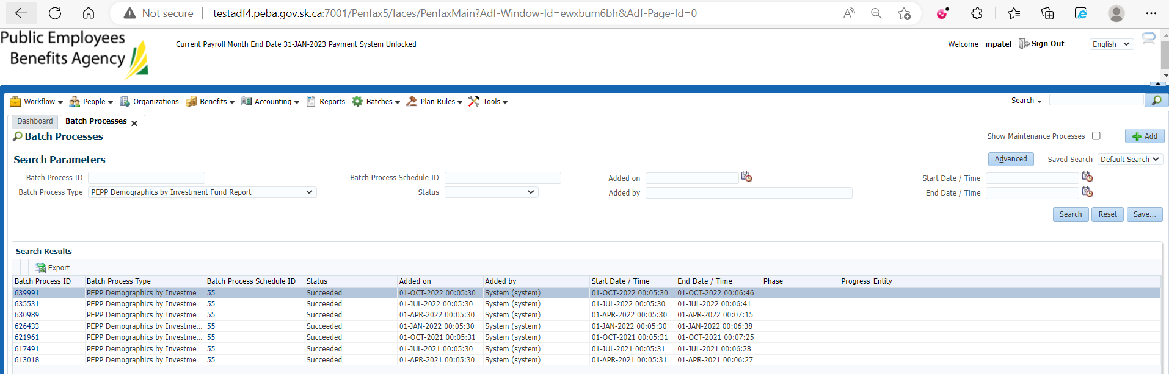

Open recent Batch Process ID

Under Files Tab PEPP_DEMOG_INVEST_FUND_RPT

Download the report

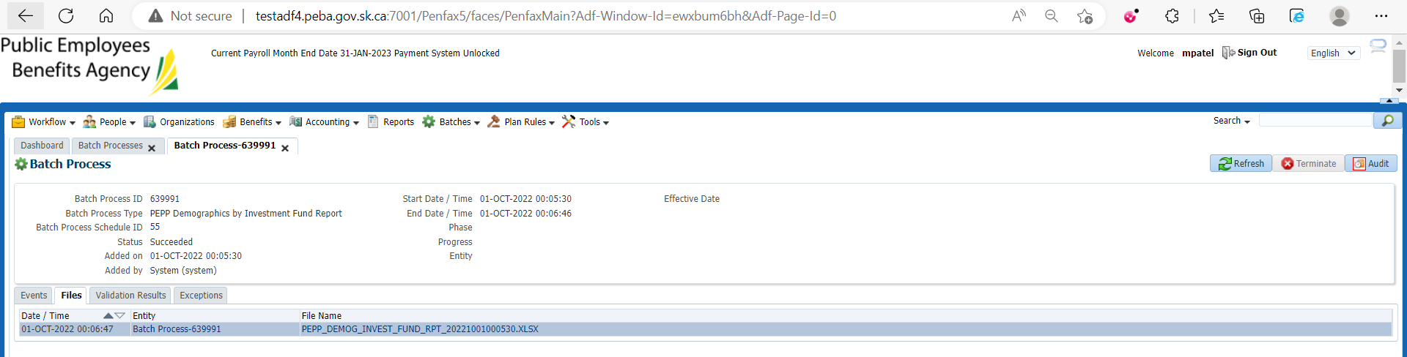

Report is as expected but cannot validate the data